# SAFE TRADE A STOCK RECOMMENDER

**MINI PROJECT REPORT**

**Submitted by**

**V.R.DikshitReddy 212219040026**

**E.GaneshReddy 212219040028**

**D.V.V.Somasekhar 212219040024**

**Degree**

**BACHELOR OF ENGINEERING in**

**COMPUTER SCIENCE AND ENGINEERING**

**SAVEETHA ENGINEERING COLLEGE(AUTONOMOUS)**

**DECEMBER 2021**

**ACKNOWLEDGEMENT**

We express our deep sense of gratitude to our honorable and beloved Founder President Dr. N. M. Veeraiyan, our President Dr. Saveetha Rajesh, our Director Dr. S. Rajesh and other management members for providing the infrastructure needed.

We express our wholehearted gratitude to our principal, Dr. N. Duraipandian, for his wholehearted encouragement in completing this project.

We convey our thanks to Dr. G. Nagappan, Professor and Head of the Department of Computer Science and Engineering, Saveetha Engineering College, for his kind support and for providing necessary facilities to carry out the project work.

We would like to express our sincere thanks and deep sense of gratitude to our Supervisor Dr. R. Kala Devi, Associate Professor, Department of Computer Science and Engineering, Saveetha Engineering College, for her valuable guidance, suggestions and constant encouragement that paved the way for the successful completion of the project work and for providing us necessary support and details at the right time and during the progressive reviews.

We owe our thanks to all the members of our college, faculty, staff and technicians for their kind and valuable cooperation during the course of the project. We are pleased to acknowledge our sincere thanks to our beloved parents, friends and well-wishers who encouraged us to complete this project successfully.

**ABSTRACT**

* **Business and finance sector is today the leader of the world’s economy,**

**Stock Market trading is a major practice in the finance sector.**

* **The project is implemented LSTM using Keras API of google’s**

**tensorflow to predict values of stock while training the algorithm on**

**past data. We concentrated on predicting the trend observed in the**

**value of a stock for the next 20 days from the day of prediction.**

* **It is basically a technique where one tries to predict the future value of**

**current stocks of a company to avoid the loss or perhaps gain profit.**

* **This project will demonstrate a machine learning approach to predict**

**the same using various quantities mentioned which is inside of it.**

* **Python is the programming language used for better reach and**

**understanding.**

**Table of Contents**

**Chapter Number Title PageNumber**

**Abstract**

**List of Figures**

**List of Tables**

**List of Abbreviations**

**1 INTRODUCTION**

* 1. **Overview of the project**
  2. **Scope and Objective**

**2 LITERATURE SURVEY**

**2.1 Introduction**

**2.2 Literature Survey**

**3 SYSTEM DESIGN**

**3.1 Introduction**

**3.2 Existing System**

**3.3 Proposed System**

**3.4 Algorithm**

**3.5 System Architecture Diagram**

**3.6 Data Flow Diagram**

**3.7 System Requirements**

**4 IMPLEMENTATION AND ANALYSIS**

**4.1 Module Description**

**4.2 Module Implementation**

**4.2.1 Getting the data**

**4.2.2 Attribute Types**

**4.3 Feasibility Study**

**4.4 Results and Analysis**

**4.5 System Design and Testing Plan**

**4.5.1 Types of Testing**

**5 CONCLUSION**

**5.1 Conclusion**

**5.2 Future Enhancement**

**Appendix A-Software Description**

**Appendix B-Sample Coding**

**Appendix C-Sample Output**

**References**

**CHAPTER 1**

**INTRODUCTION**

Business and finance sector is today the leader of the world’s economy, stock

market trading is a major practice in the finance sector. Financial exchange predictions are always trickier when it comes to stock market predictions. It is basically a technique where one tries to predict the future value of current stocks of a company to avoid the loss or perhaps gain profit. This project will demonstrate a machine learning approach to predict the same using various quantities mentioned later in the report. Python is the programming language used for better reach and understanding. We propose a Machine Learning Algorithm which will be trained from different datasets of some companies available from the past to make near effective predictions. Stock market prediction is a technique to determine the upcoming worth of a corporation’s stock market prediction, and of course, to avoid significant losses. Some individuals may disagree with the authenticity of results that these predictions considering the efficient market hypothesis that these predictions cannot be made on the presently available data, thus concluding it as inherently unpredictable. But there are numerous tools and technologies that help to gain future trend’s information, thus resulting in effective profits.

* 1. **Overview of the Project**

Stock price prediction is a popular yet challenging task and deep learning provides the means to conduct the mining for the different patterns that triggers its dynamic movement.

This project can predict the best stock to buy or sell.

It provides and efficient solution for easy investment in the stock and most important thing: the audience will not miss any point of your presentation.

Business and finance sector is today the leader of the world’s economy, stock market trading is a major practice in the finance sector. We propose a Machine Learning Algorithm which will be trained from different datasets of some companies available from the past to make near effective predictions.

As financial institutions begin to embrace artificial intelligence, machine learning is increasingly utilized to help make trading decisions. Although there is an abundance of stock data for machine learning models to train on, a high noise to signal ratio and the multitude of factors that affect stock prices are among the several reasons that predicting the market difficult. At the same time, these models don’t need to reach high levels of accuracy because even 60% accuracy can deliver solid returns. One method for predicting stock prices is using a long short-term memory neural network (LSTM) for times series forecasting.

LSTMs are an improved version of recurrent neural networks (RNNs). RNNs are analogous to human learning. When humans think, we don’t start our thinking from scratch each second. For example, in the sentence “Bob plays basketball”, we know that Bob is the person who plays basketball because we retain information about past words while reading sentences. Similarly, RNNs are networks with loops in them, which allow them to use past information before arriving at a final output. However, RNNs can only connect recent previous information and cannot connect information as the time gap grows. This is where LSTM’s come into play; LSTM’s are a type of RNN that remember information over long periods of time, making them better suited for predicting stock prices.

It has never been easy to invest in a set of assets, the abnormally of financial market does not allow simple models to predict future asset values with higher accuracy. Machine learning, which consist of making computers perform tasks that normally requiring human intelligence is currently the dominant trend in scientific research. This article aims to build a model using Recurrent Neural Networks (RNN) and especially Long-Short Term Memory model (LSTM) to predict future stock market values. The main objective of this paper is to see in which precision a Machine learning algorithm can predict and how much the epochs can improve our model.

* 1. **Scope and Objective**

Stock market consists of various buyers and sellers of stock. Stock market prediction means determining the future scope of market. A system is essential to be built which will work with maximum accuracy and it should consider all important factors that could influence the result. Various researches have already been done to predict stock market prices. The research is done over business and computer science domain. Sometime the stock market does well even when the economy is falling because there are various reasons for the profit or loss of a share. Predicting the performance of a stock market is tough as it takes into account various factors. The main aim is to identify the sentiments of investors. It is usually difficult as there must be rigorous analysis of national and international events. It is very important for an investor to know the current price and get a very close estimation of the future price.

Our objective is to identify the best possible algorithm for predicting future stock market performances. The successful prediction of the stock market will have a very positive impact on the stock market institutions and the investors also.

There are some mechanisms for stock price prediction that comes under technical analysis:

1. **Statistical method**

Statistical methods were widely used before the advent of machine learning. The popular techniques are ARIMA, ESN and Regression. The main features of statistical approach is linearity and stationarity. An analysis of statistical approaches like Linear Discriminant Analysis(LDA), regression algorithms and Quadratic Discriminant Analysis(QDA) is done. An analysis of widely used technique called ARIMA model is done. An approach to use time series as input variables is Auto-Regressive Moving Average (ARMA). ARMA model combines Auto Regressive models. ARIMA can reduce non stationary series to a stationary series and is also an extension to ARMA models.

1. **Pattern Recognition**

This method focuses on pattern detection. It studies data rigorously and identifies a pattern. Traders find buy and sell signals in Open-High- Low-Close Candlestick charts. A study is done on pattern of stock prices that can help in predicting the future of a stock. An analysis of pattern is done in by studying charts to develop predictions of stock market. A comparison of market price and its history to chart patterns for predicting future stock prediction is done.

1. **Machine learning**

Machine learning is used in many sectors. One of the most popular being stock market prediction itself. Machine learning algorithms are either supervised or unsupervised. In Supervised learning, labelled input data is trained and algorithm is applied. Classification and regression are types of supervised learning. It has a higher controlled environment. Unsupervised learning has unlabelled data but has lower controlled environment. It analyses pattern, correlation or cluster.

1. **Sentiment analysis**

Sentiment analysis is an approach that is used in relation to the latest trends. It observes the trends by analysing news and social trends like tweet activity. A study is done on using segment signals from text to improve efficiency of models to analyze trends in stock market.

**CHAPTER 3**

**SYSTEM DESIGN**

**3.1 Introduction**

Stock market prediction seems a complex problem because there are many factors that have yet to be addressed and it doesn’t seem statistical at first. But by proper use of machine learning techniques, one can relate previous data to the current data and train the machine to learn from it and make appropriate assumptions. Machine learning as such has many models but this paper focuses on two most important of them and made the predictions using them.

1. **Regression Based Model**

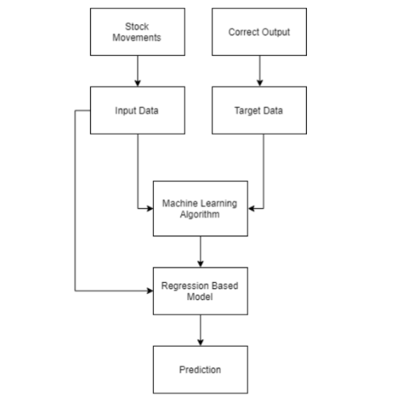

1. **Long Short Term Memory(LSTM) Model**

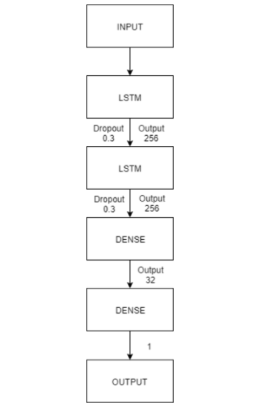

Two techniques have been utilized LSTM and Regression, on the prediction of the stock dataset. Both the techniques have shown an improvement in the

accuracy of predictions, thereby yielding positive results. Use of recently introduced machine learning techniques in the prediction of stocks have yielded promising results and thereby marked the use of them in profitable exchange schemes. It has led to the conclusion that it is possible to predict stock market with more accuracy and efficiency using machine learning techniques.

**3.2 Existing System**

In the existing system, SVM and Backpropagation Algorithm there is no which won't do dropout process. Because of this, unwanted data have been processed which leads to wastage of time and memory space. The prediction of future stock price by SVM and Backpropagation Algorithm is less efficient because of processing unwanted data. The SVM and Backpropagation Algorithm which is used in the existing system is not that effective in handling non-linear data. So, in our proposed future stock price prediction is done using LSTM (Long ShortTerm Memory) which is a higher accurate value for the next day than SVM and Backpropagation Algorithm.

**3.3 Proposed System**

In the proposed system we try to find the accurate value of the next day closing value that helps the investors to invest or sell their shares. Long Short Term Memory (LSTM) is an artificial neural network in the field of deep learning. LSTM is an advance Neural network with having a memory cell that stores a small amount of data for further references. LSTM has feedback links that make it a "general-purpose computer". LSTM can also process an entire series of data not only single value like image. Because of the dropout process which takes place in the LSTM algorithm, it is comparatively faster than SVM and Backpropagation. LSTM algorithm is more suitable in predicting the future stock price than the SVM and Backpropagation algorithm because of removing the undesired data. The time and memory consumption are also reduced when compared to the exciting system due to the dropout process. LSTM algorithm is more proper in handling non-linear data. We predict the 10-company stock price and store them in a tabular format and visualize the.

Deals with the classification of brain tumor accurately from the source, big data based on Hadoop framework with SVM classifier.

The proposed methodology consists of the following modules:

1. Elimination of Secondary attributes
2. Clustering and Classification

**3.4 Algorithm**

Here we have used the most popular algorithm named LSTM-Long Short Term Memory.

The implementation will in the following set of order.

1. **Loading the dataset.**

The next step is to load in our training dataset and select the Open and Highcolumns that we’ll use in our modeling.

We check the head of our dataset to give us a glimpse into the kind of dataset we’re working with.

The Open column is the starting price while the Close column is the final price of a stock on a particular trading day. The High and Low columns represent the highest and lowest prices for a certain day.

1. **Feature Scaling**

From previous experience with deep learning models, **we know that we have to scale our data for optimal performance**. In our case, we’ll use Scikit-Learn’s MinMaxScaler and scale our dataset to numbers between zero and one.

1. **Creating Data with Time Steps**

LSTM expect our data to be in a specific format, usually a 3D array. We start by creating data in 60 time steps and converting it into an array using NumPy. Next, we convert the data into a 3D dimension array with X_train samples, n timestamps, and one feature at each step.

1. **Building the LSTM**

In order to build the LSTM, we need to import a couple of modules from Keras:

Sequential for initializing the neural network.

Dense for adding a densely connected neural network layer.

LSTM for adding the Long Short-Term Memory layer.

Dropout for adding dropout layers that prevent overfitting.

1. **Predicting the future stock**

In order to predict future stock prices we need to do a couple of things after loading in the test set:

Merge the training set and the test set on the 0 axis.

Set the time step as 60 (as seen previously).

Use MinMaxScaler to transform the new dataset.

Reshape the dataset as done previously.

1. **Plotting the Results**

Finally, we use Matplotlib to visualize the result of the predicted stock price and the real stock price.

**3.5 System Architecture Diagram**

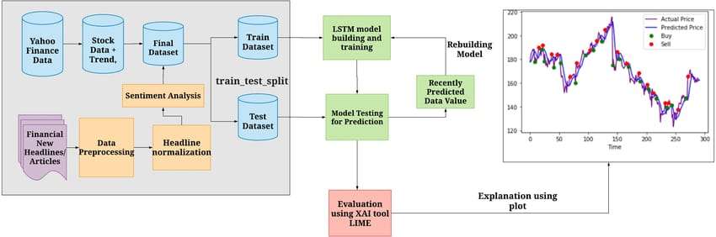

**3.6 Data Flow Diagram**

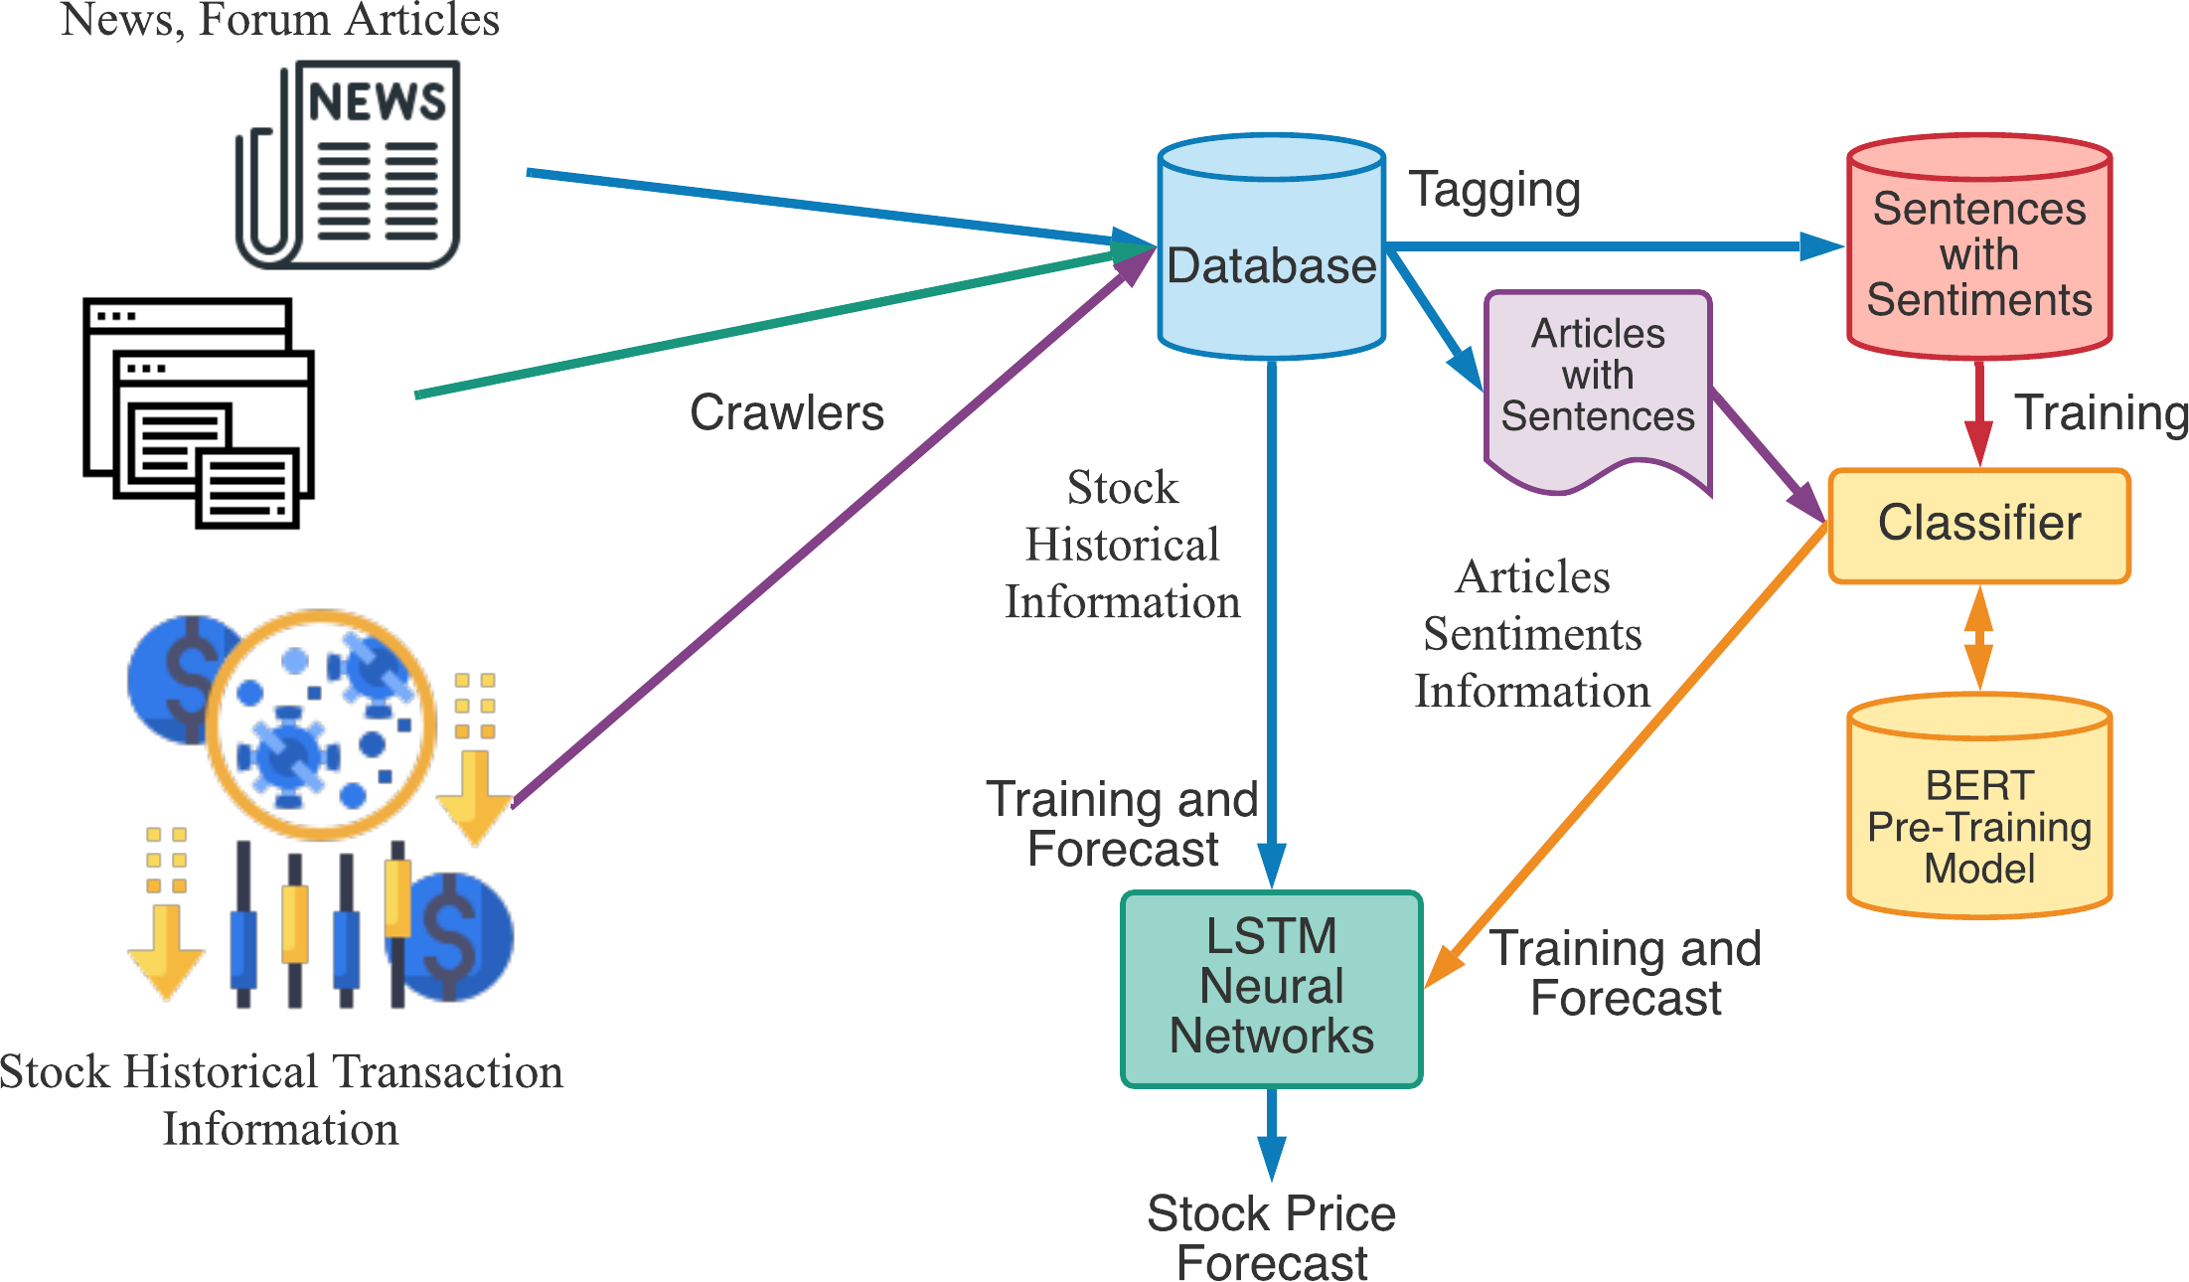

**3.7 System Requirements**

A system of Minimum 8GB RAM & installed the following packages.

1. HTML
2. CSS
3. JYUPTER NOTEBOOK
4. JAVASCRIPT
5. PYTHON

The system must contain the following libraries in order to implement the code:

1. Numpy

Fundamental package for scientific computing in python3, helping us in creating and managing n-dimensional tensors. A vector can be regarded as a 1-D tensor, matrix as 2-D, and so on.

1. Matplotlib

A python3 plotting library used for data visualization.

1. Tensorflow keras

Is an open source deep learning frame work for dataflow and differentiable programming. It’s created and maintained by Google.

1. Pandas

Used for data manipulation and analysis. In particular, it offers data structures and operations for manipulating numerical tables and time series.

1. Sci-kit Learn

Scikit-learn is a free software machine learning library for the Python programming language. It features various classification, regression and clustering algorithms including support vector machines and many more.

**CHAPTER 4**

**IMPLEMENTATION AND ANALYSIS**

* 1. **Module Description**

Modules deal with the flexibilities and the top marks that one can present. The project was headed with the resource available and the most that the company demands and that is finance. Taking about finance and learning on the same gave an idea on the fiscal and stocks. So featuring of the idea came with handling and automating the resource which other agents are making fortune out of it.

Knowledge is a bliss and learning is the curiosity whereas outcome is the expectation so the resource deals with the importation and extraction of multiple machine learning algorithms to learn, process and yield the result to derive and conclude a possible outcome set that is effective and generative in nature.

**4.2 Module Implementation**

**4.2.1 Getting the data**

This is the fundamental module before starting of the project. The dataset is a group of data that are mended together to show the data variations in a time span to undergo further estimation and the source of the resources and its outcome for the later time of evaluation. It generates the result optimization and gives a feasible time period to customize and get the flow to the derivation. This increases and are used in the level of research and finding the best suitable resource out of the same the resources has to be finely estimated and derived for the best possible outcome and the finest the value become the better is the level of extraction and closure is the best yield values that needs to be considered.

**4.2.2 Attribute Types**

These are the sets of data that gives the result after learning from the data. This is the test generation with the output result. Results are generated in each phase of testing. This is also termed as the testing phase. Now a new set of datasets are passed which are deliberately like the training dataset and the efficiency of the same is calculated.

* 1. **Feasibility Study**

One of the integral part to maintain the consistency is the literature survey. It’s the crucial steps to be followed in the development process. The Software Development needs authenticity of the resources and the availability of the same. This part helps in discovering the content that been worked on and find the utilization and the implementation of the same in today’s time. The key factor to the development is the economy and the strength of the product. Once the innovation of the same undergoes through the building phase the support and the resource flow is to be monitored and computed. This is also known as the Research phase where all the research is embedded and done to carry the flow.

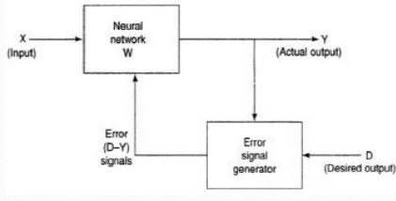

**4.4 Results and Analysis**

As the integration of the same is higher with other dependencies so leaving one dependencies compromises the level of accuracy. Accuracy is not the term used over in stock as the actual prediction is not possible for any fiscal days it keeps on changing and turning the tables day and night. Having higher component assets and the dependencies makes it more feasible and flexible in nature causing it even harder to predict. The approx value are taken into consideration and the hit or profit or the gain rate is calculated for the same.

In the project various high level machine learning algorithms are implemented and integrated and the output is generated from the same making a user visible with the outputs in the form of graph which makes it easier for them to see and interpret what’s the scenario and they can decide on the same to invest and get the benefit out of it.

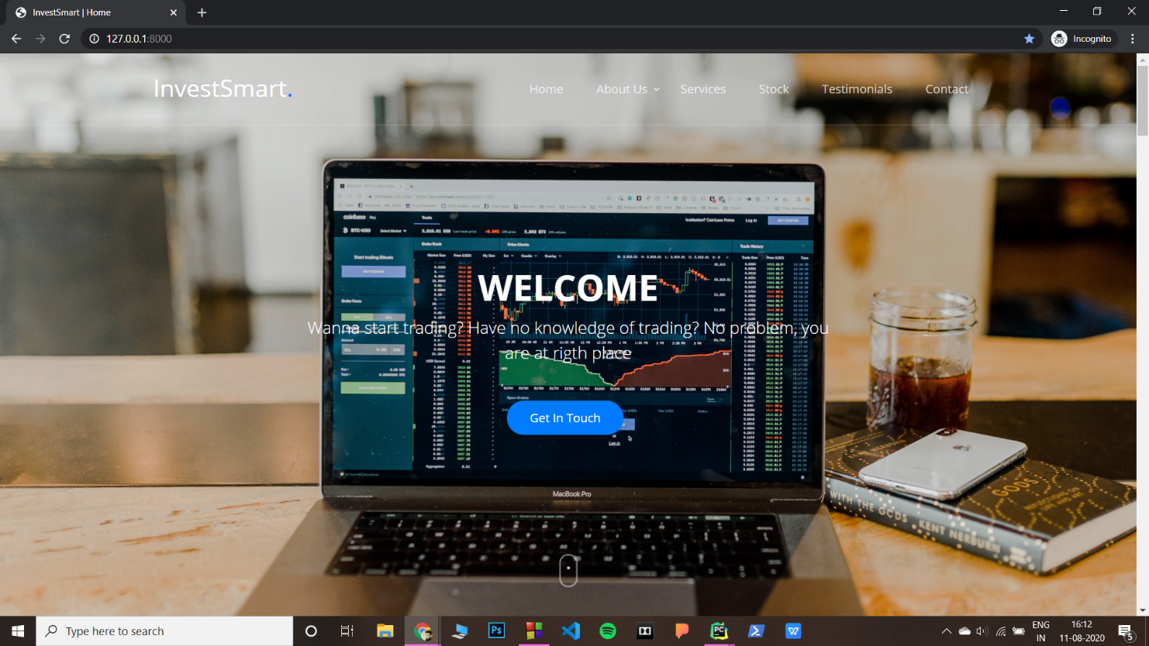

**4.5 System Design and Testing Plan**

This section provides an elaboration of the detailed technical system design as being a comprehensive solution based on utilizing, combining, and customizing several existing data preprocessing, feature engineering, and deep learning techniques. Figure provides the detailed technical design from data processing to prediction, including the data exploration. We split the content by main procedures, and each procedure contains algorithmic steps. Algorithmic details are elaborated in the next section. The contents of this section will focus on illustrating the data workflow.

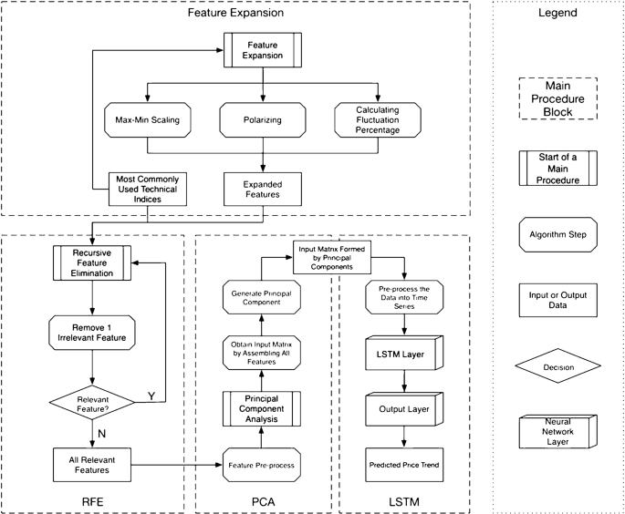

**4.5.1 Types of Testing**

The purpose of testing is to get errors. Testing is that the process of trying to get every conceivable fault or weakness during a work product. It provides how to see the functionality of components, sub-assemblies, assemblies and/or a finished product it's the method of exercising software with the intent of ensuring that the software meets its requirements and user expectations and doesn't fail in an unacceptable manner. There are various sorts of test. Each test type addresses a selected testing requirement. The various types of testing that follows are listed as below.

**UNIT TESTING**

Unit testing involves the planning of test cases that validate that the interior program logic is functioning properly, which program inputs produce valid outputs. All decision branches and internal code flow should be validated. it's the testing of individual software units of the appliance.

It is done after the completion of a private unit before integration. this is often a structural testing, that relies on knowledge of its construction and is invasive. Unit tests perform basic tests at component level and test a selected business process, application, and/or system configuration.

**INTEGRATION TESTING**

Integration tests are designed to check integrated software components to work out if they really run together program. Testing is event driven and is more concerned with the essential outcome of screens or fields.

Integration tests demonstrate that although the components were individually satisfaction, as shown by successfully unit testing, the mixture of components is correct and consistent. Integration testing is specifically aimed toward exposing the issues that arise from the mixture of components.

**VALIDATION TESTING**

Validation testing is that the process of ensuring if the tested and developed software satisfies the client/user needs. The business requirement logic or scenarios need to be tested intimately. All the critical functionalities of an application must be tested here.

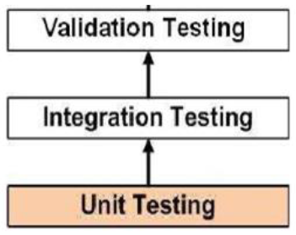

**SYSTEM TESTING**

System testing of software or hardware is testing conducted on an entire, integrated system to guage the system's compliance with its specified requirements. System testing falls within the scope of recorder testing, and intrinsically, should require no knowledge of the inner design of the code or logic.

As a rule, system testing takes, as its input, all of the "integrated" software components that have successfully passed integration testing and also the software itself integrated with any applicable hardware system(s).

System testing may be a more limited sort of testing; it seeks to detect defects both within the "inter-assemblages" and also within the system as an entire.

System testing is performed on the whole system within the context of a  
Functional Requirement Specification(s) (FRS) and/or a System Requirement Specification (SRS).

System testing tests not only the planning, but also the behavior and even the believed expectations of the customer. it's also intended to check up to and beyond the bounds defined within the software/hardware requirements specification(s).

**CHAPTER 5**

**CONCLUSION**

**5.1 Conclusion**

To conclude stock is an unpredictable mechanism which follows the segments of chain and the dependencies of the same are unpredictable. It is defined to be a curve which keeps on changing and turning the price from low to high and vice-versa.

As the integration of the same is higher with other dependencies so leaving dependencies compromise the level of accuracy. Accuracy is not the term used over in stock as the actual prediction is not possible for any fiscal days it keeps on changing and turning the tables day and night. Having higher component assets and the dependencies makes it more feasible and flexible in nature causing it even harder to predict. The approximate values are taken into consideration and the hit or profit or the gain rate is calculated for the same.

In the project various high level machine learning algorithms are implemented and integrated and the output is generated from the same making a user visible with the outputs in the form of graph which makes it easier for them to see and interpret what’s the scenario and they can decide on the same to invest and get the benefit out of it.

The proposed software takes the raw set of data from the dataset or the .csv file and process it. The cleaning and cleansing of data is done and then further processed to gain the effective outcomes. After the computational mean the output is displayed in the screen in the form of graph.

Stocks are important to a business because they can help the corporation quickly gain a lot of capital, raise the prestige of the company with the public since people can now invest in the company, and allow the initial investors to sell off shares and earn money on their investments. We provide an efficient solution for easy investment in the stock market, so that a layman can also benefit without having prior knowledge of technicalities that a stock market carries. The Website is named as **SafeTrade** and it helps people invest smartly, the number of various examples belonging to each class were identified and plotted.

**5.2 Future Enhancement**

Stock Market are the best alternative for business to grow and it’s a side way income for the individuals who are ready to invest and earn from the same. The term stock had been in picture ever since and it’s growing in bulk everyday. There are thousands of investors investing on the same and making the fortune out of it.

There are middle level agents and stock vendors who learn and invest on the same. The cost for the consultation on the stock is bulky and expensive. So when it comes to people they think a lot and invest and there’s no chance and certainty for the same to produce a yieldful result.

So stock being unpredictable and the tendency of its growth is higher than ever. If the stock market and its prediction can be done accurate than it’s going to be a gain for both the individuals and the organization. The risk factor have to be mitigated so the efficiency of the system should be high and people can be certain about their investment in time.

The project can be further continued to gain the effectiveness of the prediction with addition implementations of the content that can involve real time scenario and the way of executing and processing the real time scenario. Various constrains has to be added and performance of the same can be acylated in the future time for the effective results. The expected form of the display is graph where as from the same the more appearance and setting of the display can be integrated and a pie-chart and a custom graph can further me implemented on the same.

**Appendix A**

**Software Description:**

## **Numpy:**

Fundamental package for scientific computing in Python3, helping us in creating and managing n-dimensional tensors. A vector can be regarded as a 1-D tensor, matrix as 2-D, and so on.

## **Pandas:**

Used for data manipulation and analysis. In particular, it offers data structures and operations for manipulating numerical tables and time series. Pandas allows us to analyse big data and make conclusions based on statistical theories. Pandas can clean messy data sets, and make them readable and relevant. Relevant data is very important in data science.

**Tensorflow:**

[TensorFlow](https://www.tensorflow.org/) is an end-to-end open source platform for machine learning. It has a comprehensive, flexible ecosystem of [tools](https://www.tensorflow.org/resources/tools), [libraries](https://www.tensorflow.org/resources/libraries-extensions), and [community](https://www.tensorflow.org/community) resources that lets researchers push the state-of-the-art in ML and developers easily build and deploy ML-powered applications.

TensorFlow was originally developed by researchers and engineers working on the Google Brain team within Google's Machine Intelligence Research organization to conduct machine learning and deep neural networks research. The system is general enough to be applicable in a wide variety of other domains, as well.

TensorFlow provides stable [Python](https://www.tensorflow.org/api_docs/python) and [C++](https://www.tensorflow.org/api_docs/cc) APIs, as well as non-guaranteed backward compatible API for [other languages](https://www.tensorflow.org/api_docs).

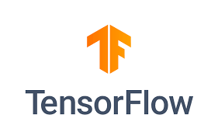

**Appendix B**

**Sample Coding:**

**manage.py**

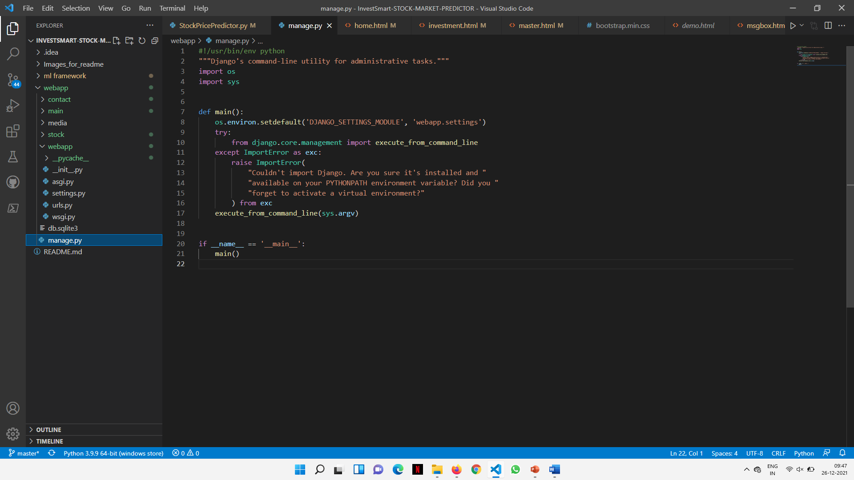

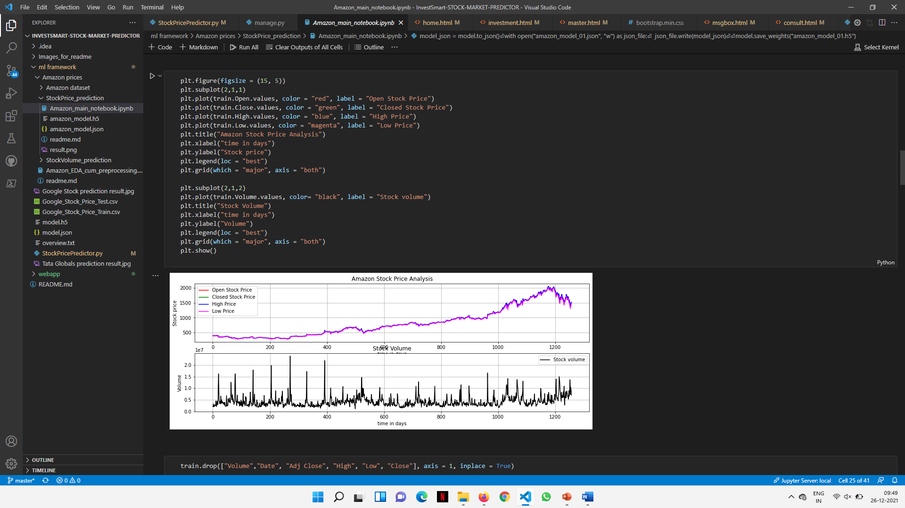

**Appendix C**

**Sample Output:**

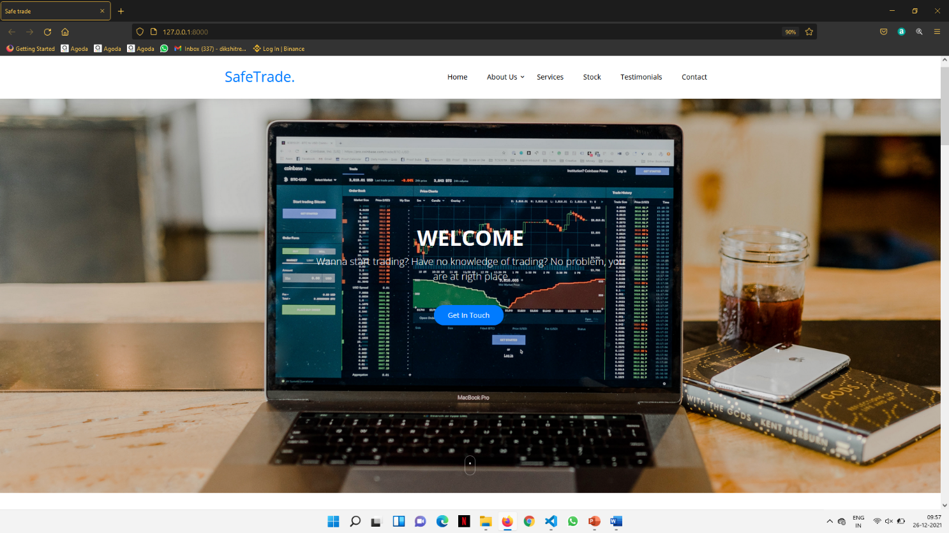

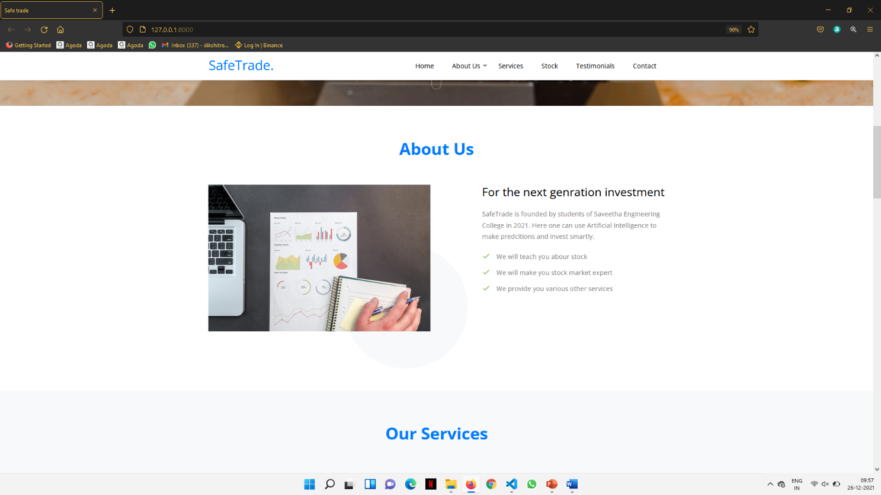

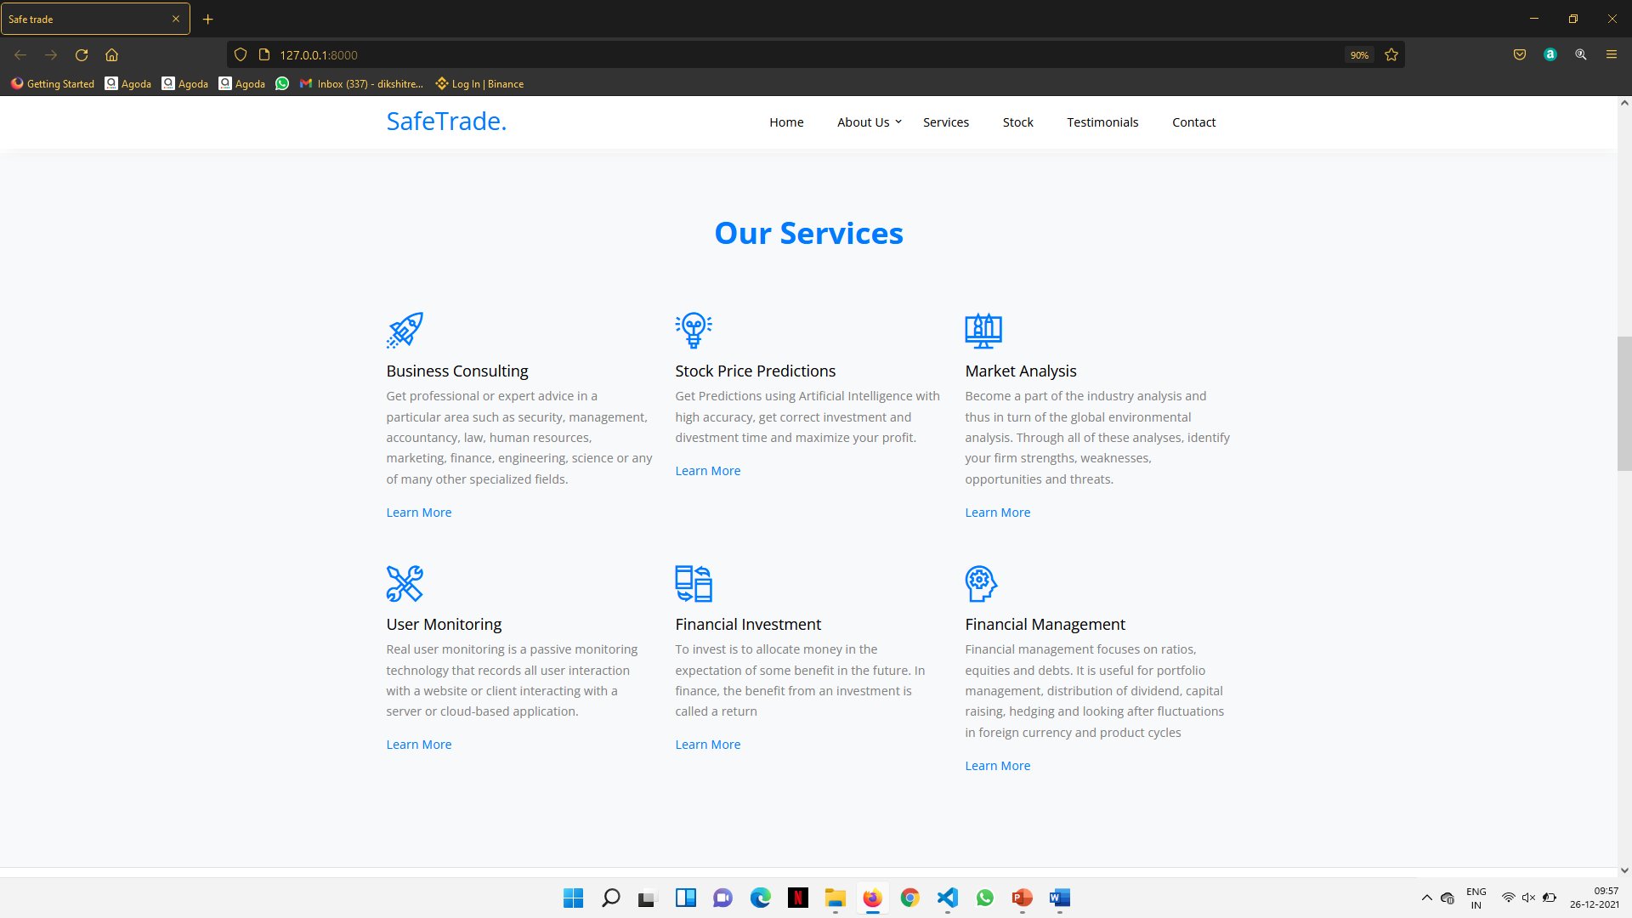

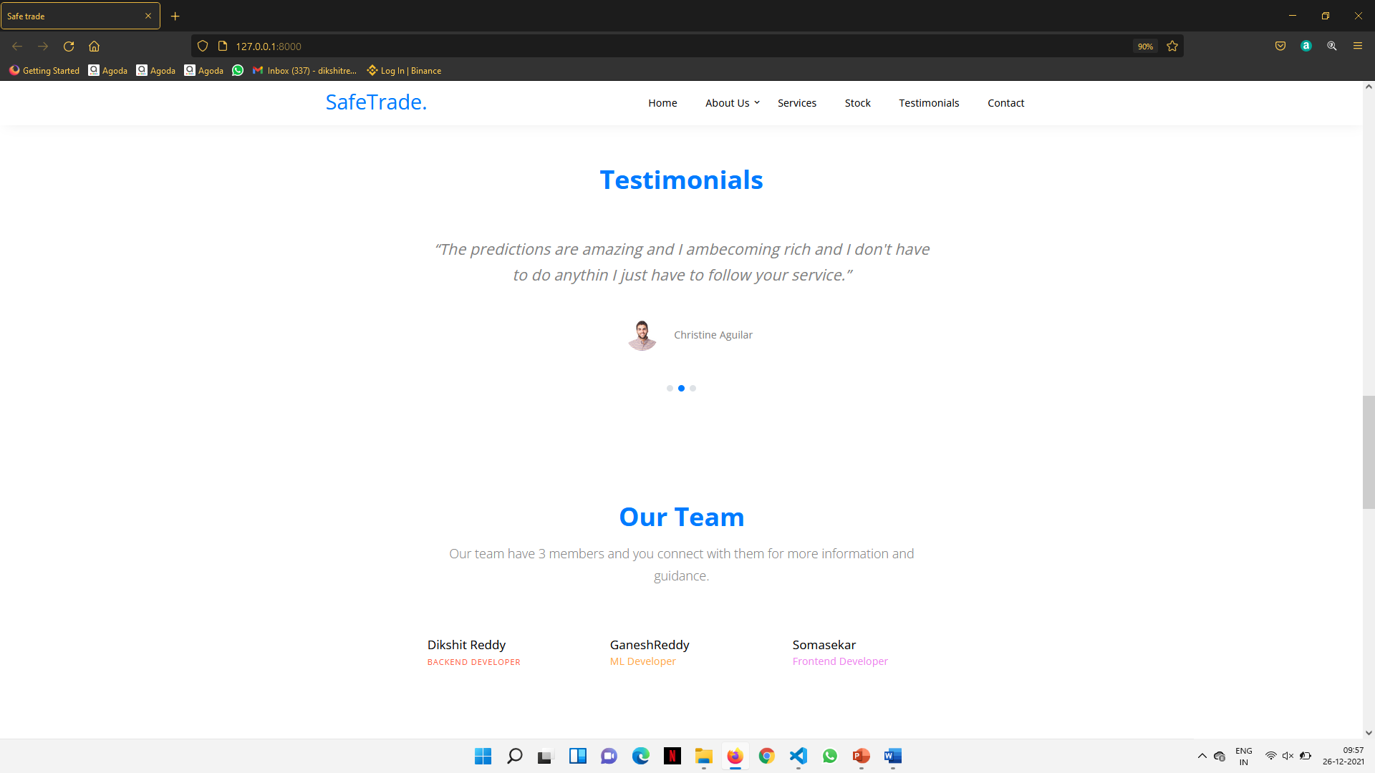

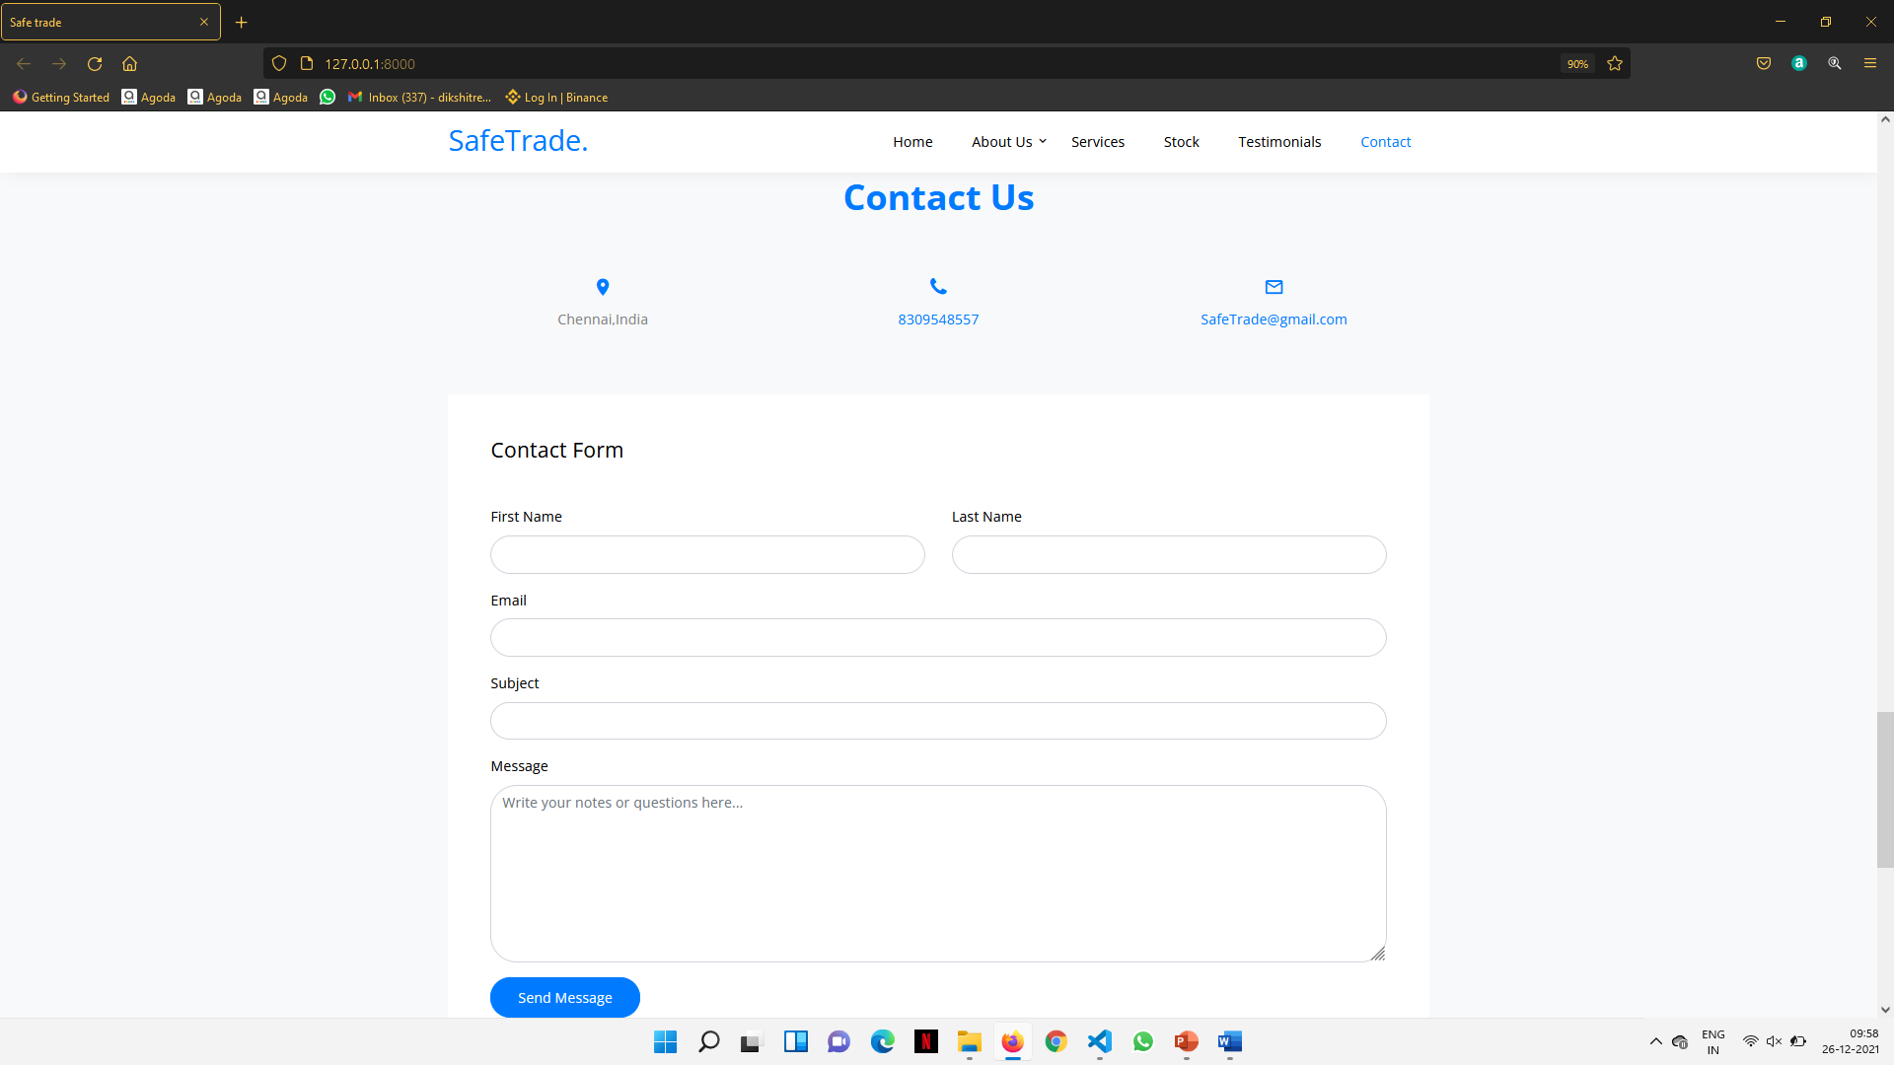

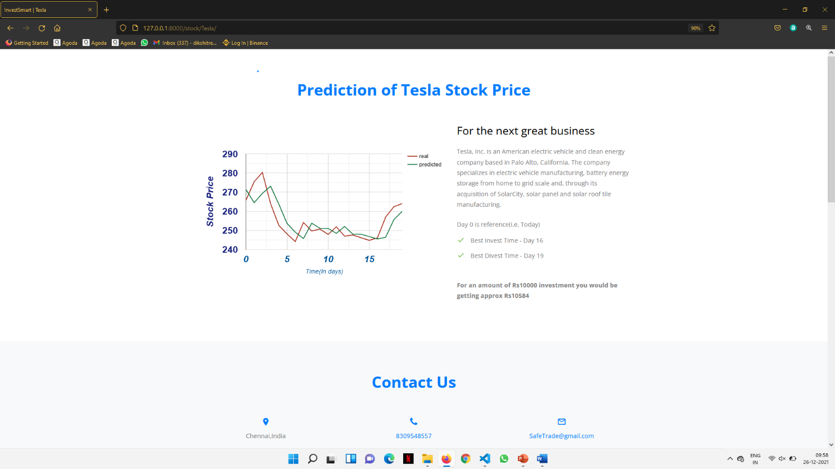

**References**

1.[A Novel Algorithmic Trading Strategy Using Data-Driven Innovation](https://ieeexplore.ieee.org/document/9308360/) Publisher: IEEE – 2020 Author : Md.Erfanul

2.[Stock Price Prediction Model Based on RBF-SVM Algorithm](https://ieeexplore.ieee.org/document/9361804) Publisher: IEEE – 2021 Author : Zixuan Liu

3.[Stock Market Analysis using Supervised Machine Learning](https://ieeexplore.ieee.org/document/8862225)

Publisher: IEEE – 2018 Author: Kunal Pahwa, Neha Agarwal

4.[Stock Market Prediction Using Linear Regression and SVM](https://ieeexplore.ieee.org/document/9404733)

Publisher: IEEE – 2020 Author: Bhawna Panwar, Gaurav

5. [Deep Learning-Based Stock Price Prediction Using LSTM and Bi-Directional LSTM Model](https://ieeexplore.ieee.org/document/9257950) Publisher: IEEE – 2020 Author: Md. Arif Istiake Sunny, Mirza Mohd